**Logo Web**

**Enhancement**

Contents

1. Business Requirements: 3

2. Logo (Current flow): 4

3. Logo (Proposed flow): 6

4. Impact: 7

# Business Requirements:

1. Logo Dimension restrictions should not come.
2. It should allow only less than or equal to 5Mb file size
3. Formats validations should come.

# Logo (Current flow):

1. When user tries to upload the logo with width less than 160 px then it auto calculates its size based on uploaded image. But the image is not auto fit in the logo area (**Screen 1**) (**Screen 2**).

Screen 1

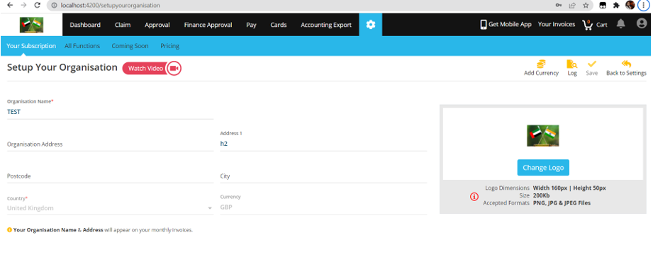

Screen 2

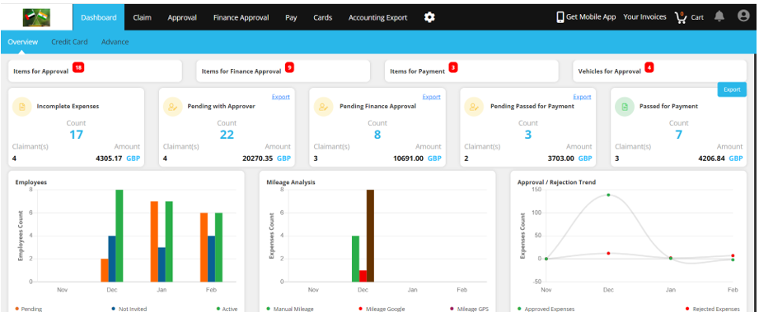

1. When user tries to upload the logo with 160 width and 50 px height then it auto calculates its size based on uploaded image. But the image is not auto fit in the logo area (**Screen 3**)(**Screen 4**).

Screen 3

Screen 4

1. When user tries to upload the logo with height less than 50 px then it auto calculates its size based on uploaded image. But the image is not auto fit in the logo area

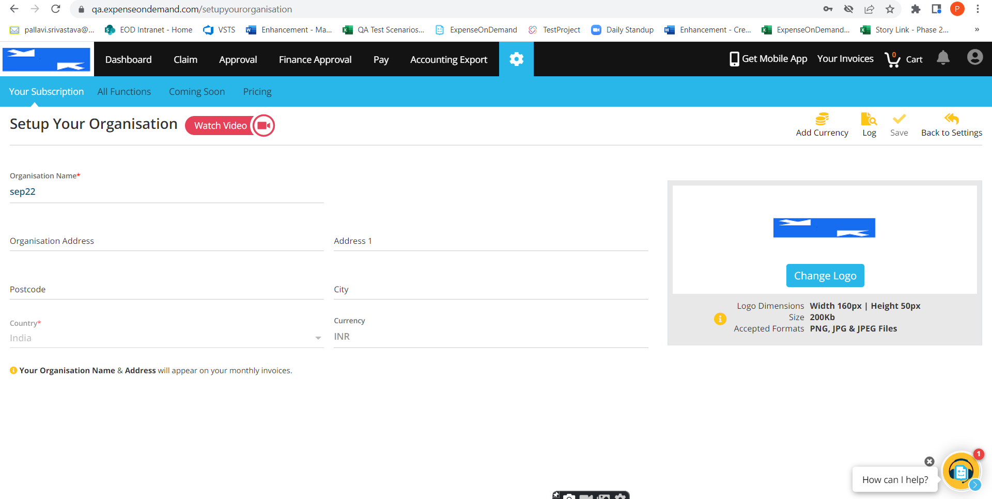

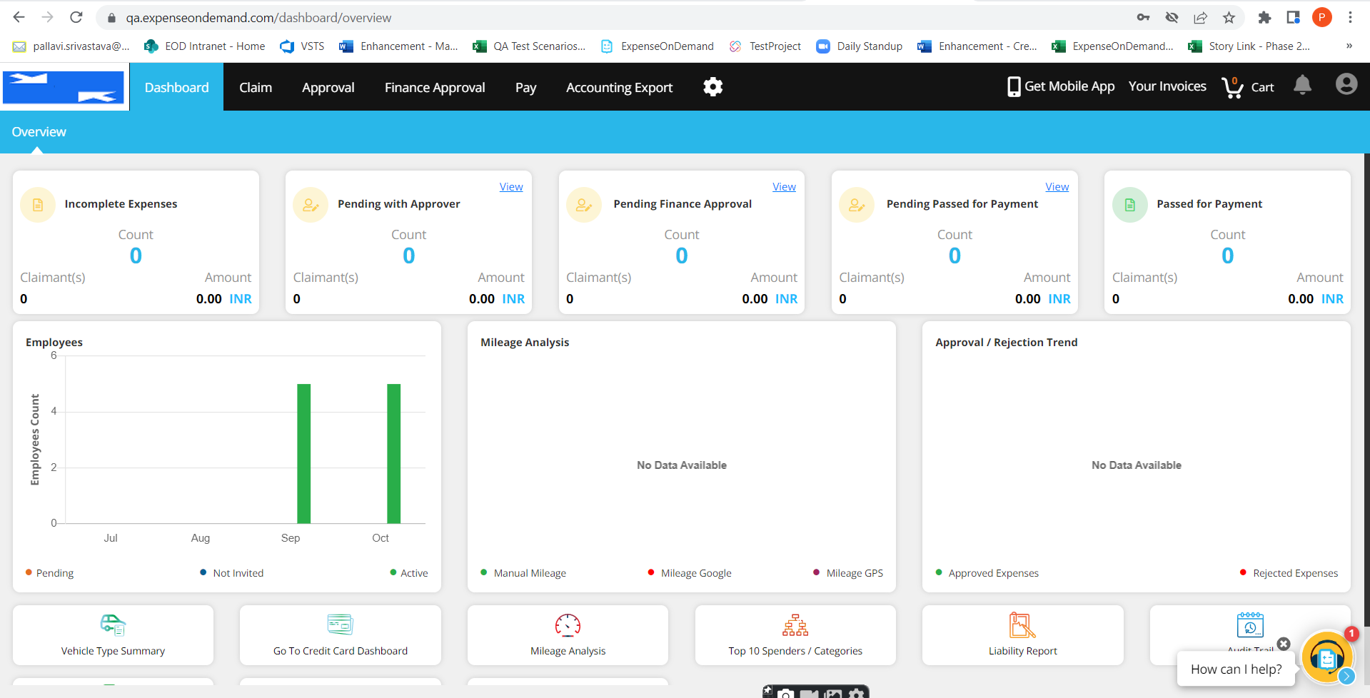

1. When user tries to upload the logo with width greater than 160 px or height greater than 50 px, then it does not allow to upload the image.

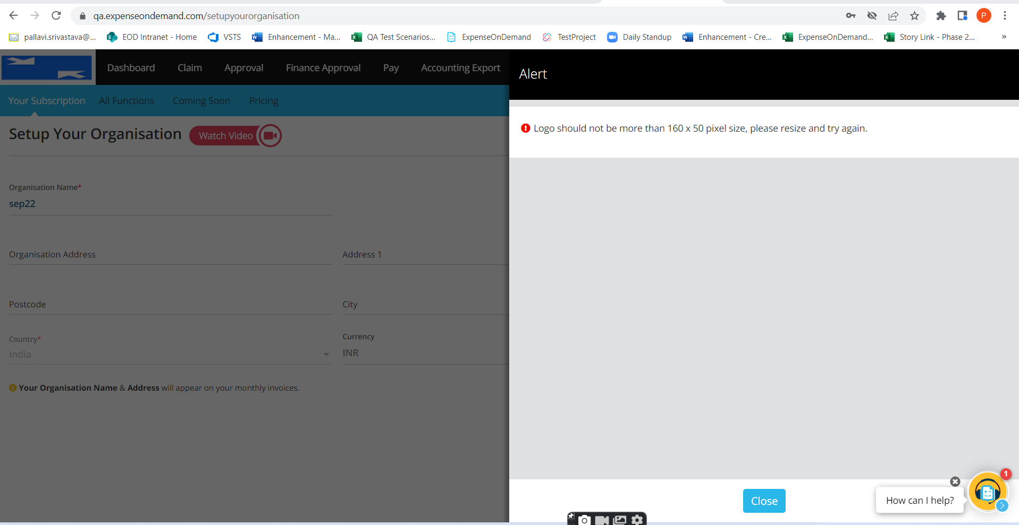

# Logo (Proposed flow):

1. Logo with all the sizes should get auto fit in the logo area on web and Mobile
2. It should allow only less than or equal to 5Mb file size
3. Formats validations should come. It should only allow PNG, JPG and JPEG format files.

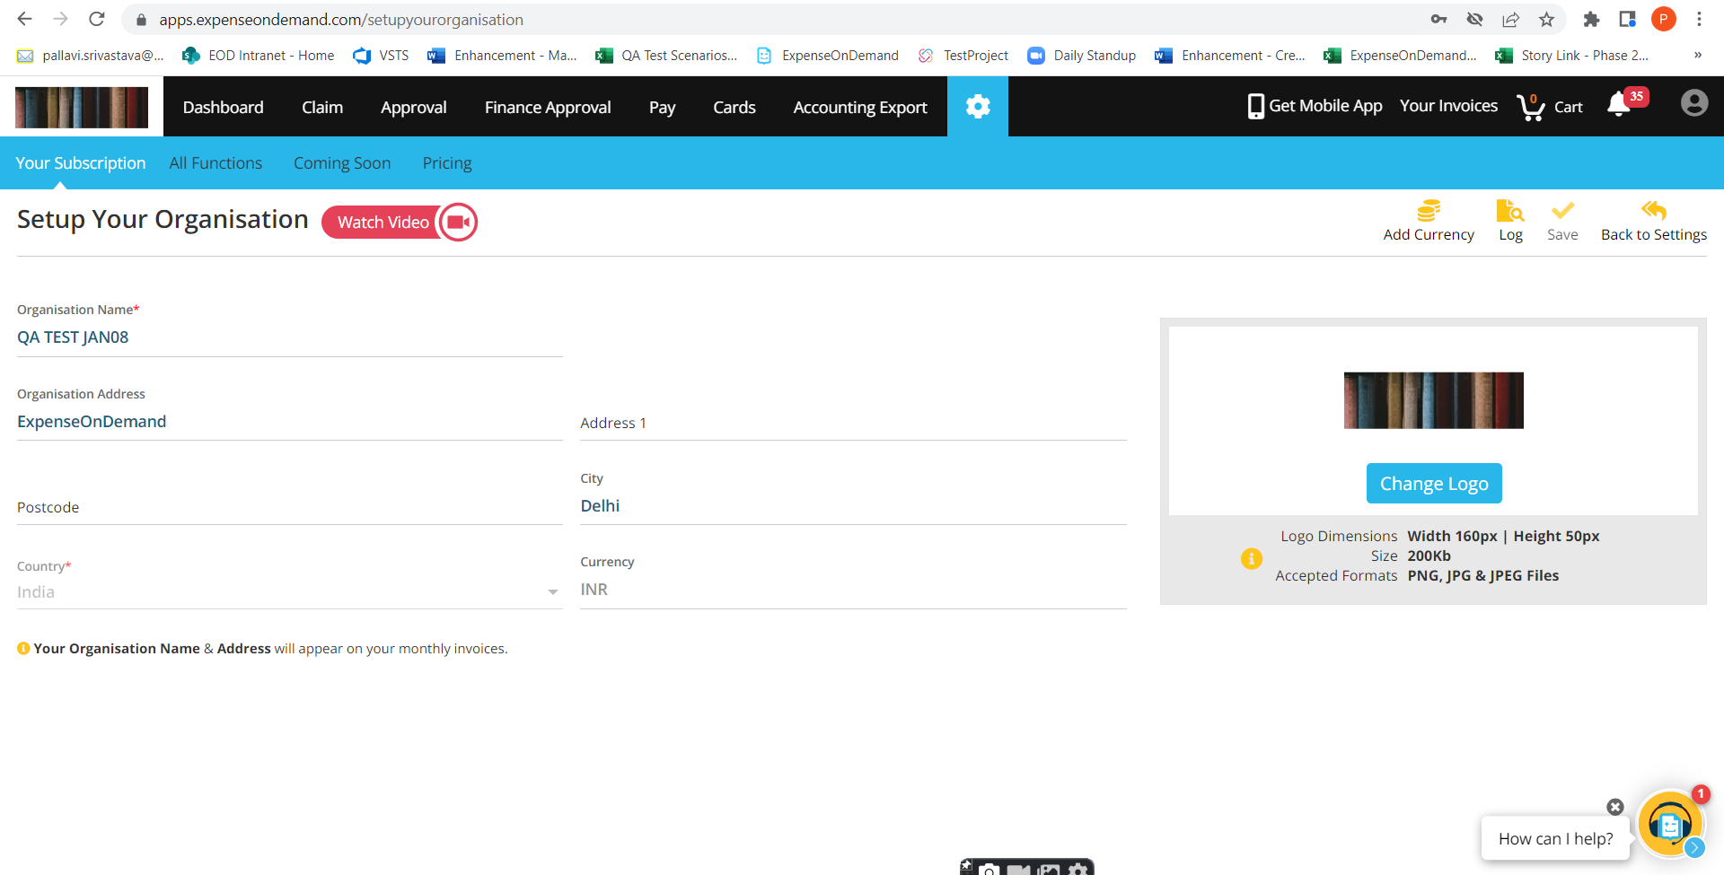

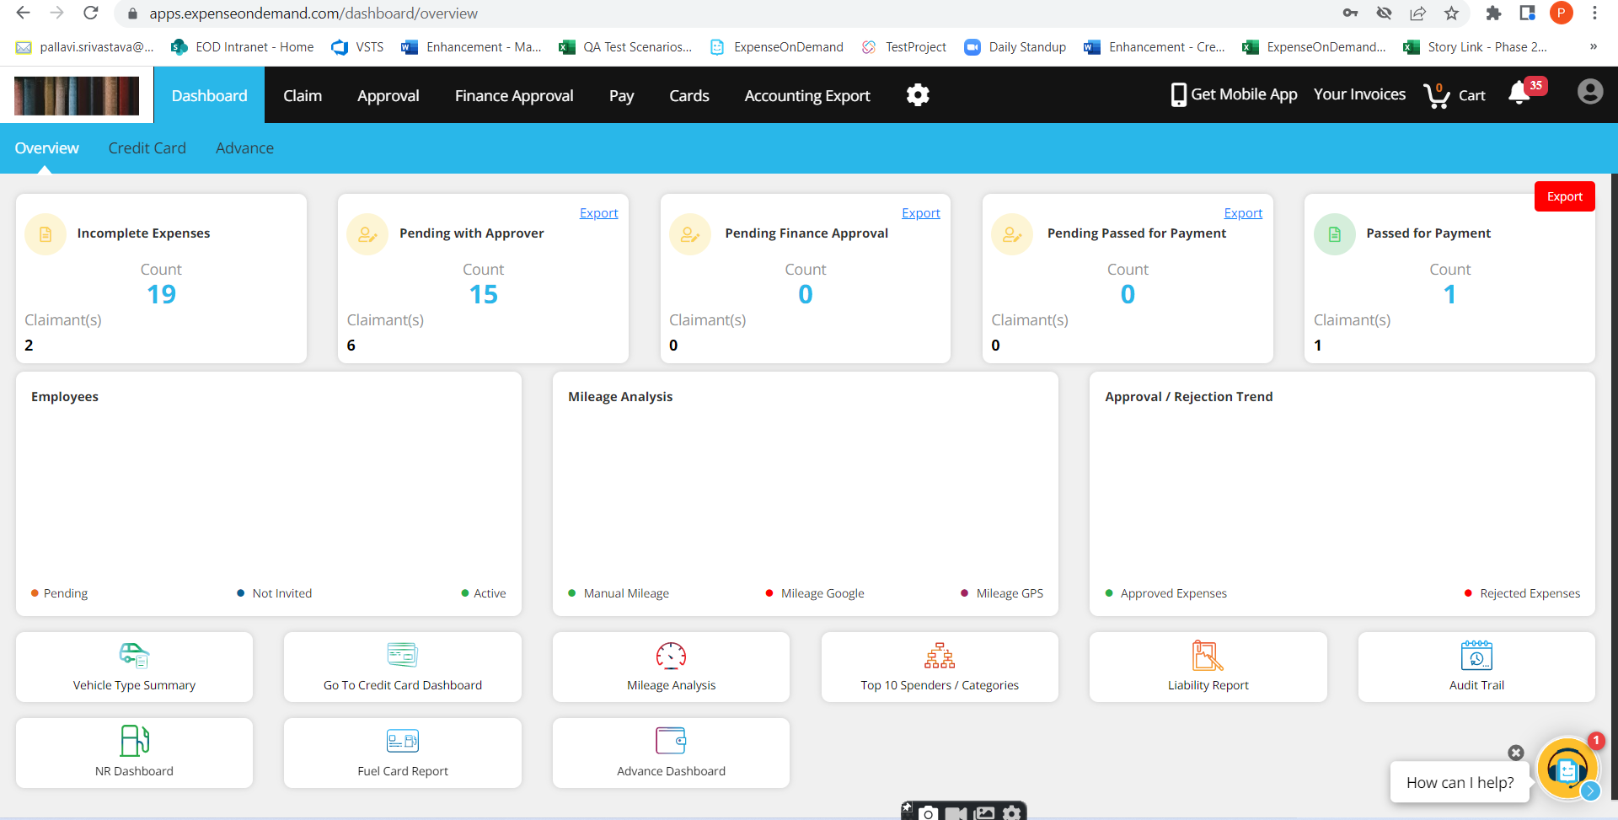

# Impact:

1. There is no impact of this enhancement on any other functions of the application.